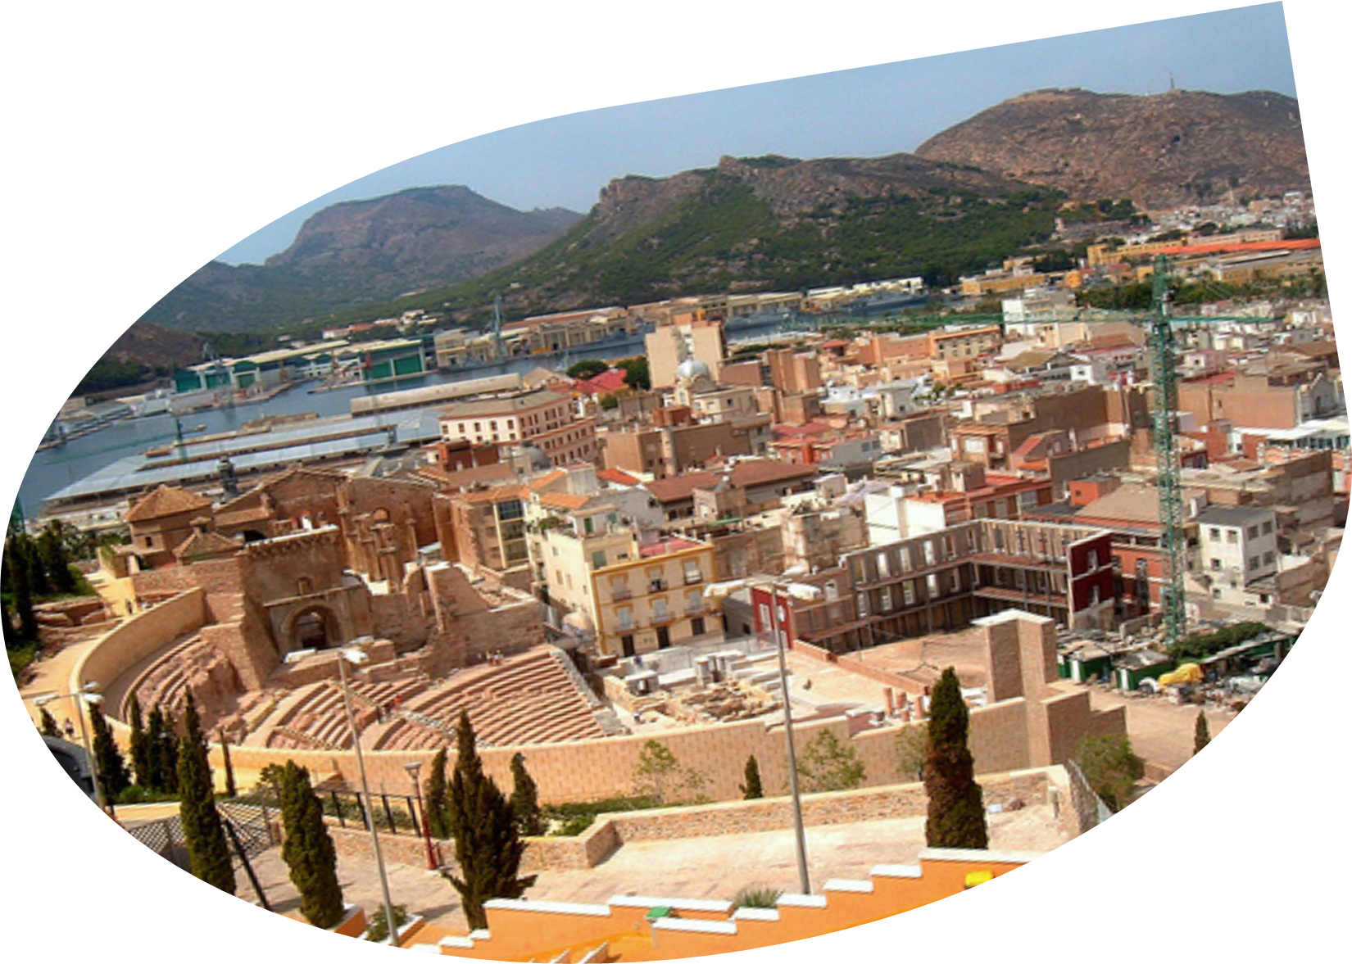

“DESCUBRE EUROPA”
European programme: Europe for citizens
« Democratic engagement and civic participation»

Agence du Développement Local et de l’Emplois de Cartagena

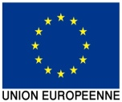
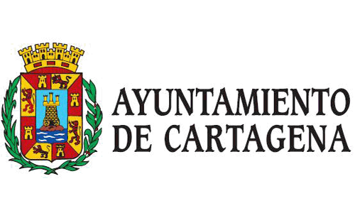


- GENERAL OBJECTIVE:

The objective being to encourage and to facilitate the participation of citizens in local and European Union policies, while using the new technologies, social networks to enable the strengthening of institutions.

Specifics objectives

- Awareness and information about the functioning of institutions and policies developed of the EU.

- Establish local and transnational networks of discussion and analysis of the priorities of the European Union.

- Promote and facilitate the participation of the public in European affairs.

- Promote the debate on EU policies accepting the sharing of the problems and the solutions in European and local interest

- Spread the policies and objectives of the EU, by participating citizens in the local domain.

Transnational objectives

- Improving the quality of life of European citizens

- Promote the Equality of opportunities between men and women and different cultures.

- Promote the new technologies that allow the knowledge and participation of citizens in the ​​general subject of interest.

- Actions
- Establishment of a Transnational Network
- Campaign of distribution and the promotion of the project
- Organization Workshops, Seminars and Events
- Program of direct participation of the citizen

- Durations 18 Month.
- Rising of the requested subsidy: 150.000 €.

- Person to contact

Fulgencio Luis Cerón Mora
C/ Caridad nº 1 (Casa Moreno)
30202 Cartagena Murcia
- Email: fceron.adle@ayto-cartagena.es
- adle@ayto-cartagena.es
- TLF:+34 968128977 ext 7678
- Fax : 968 52 37 06

